**Catering Industry**

**Stakeholders**

| **ACTOR** | **What they can do on the software created** |
| --- | --- |
| Employee/Customer | * Order lunches on given time slots. * They will be able to edit the orders as many times as they want, before confirming the application. * Provide feedback on the food items they ordered, so that the Canteen Management can have a better perspective on the condition of food items. |
| Canteen Manager | * Confirm orders from employees and pass it on to the Delivery Team. * Also account for the Total price for orders on a monthly basis along with the Leftover Fines, that needs to be deducted from the Employees salary. * Present Up-to-date Menu Systems for the Employees |
| Delivery Boy | * Delivery Boys will be responsible for all the deliveries in a particular floor. * They will also be responsible for picking up the leftovers for each person, and update the canteen manager regarding food wastage for each of them. |
| Payroll system | * At the end of each month, the Payroll System will deduct money from the Employee’s salary, along with the Leftover Fine and send it to the Canteen Manager |
| Management | * Should observe reports from the Business Analysts and make sure everything operates efficiently. * Make sure there is enough supply of food items for everyone and discuss with the Canteen Manager about constantly improving the quality of food and the canteen. * Keep tabs on the order payment details for each employee, which he will receive from the Canteen Manager. * Working on Partnerships with Snack companies to get a higher supply of readymade food |

**Problem Definition and Solution**

* Employees take 30 - 35 minutes to get in line, order food and then wait for seats to get empty, whereas they finish with their meal in 10 - 15 minutes. Not to mention employees also take another 10 minutes to go to and come back from the cafeteria. This results in lack of productivity for the Employees and the Company, as a lot of time gets wasted.
* Employees don’t always get their choice of food they want because the canteen runs out of certain items. The canteen wastes a significant quantity of food by throwing away what is not purchased.

**Advantages and Objectives**

Advantages of the Canteen Ordering System:

* A system would save considerable time to those employees who use the service.
* It would increase the chance of them getting the food items they prefer.
* This would improve both their quality of work life and their productivity.
* This will reduce the cost.
* The food wastage will be reduced.

**Objectives:**

* Reduce canteen food wastage by a minimum of 30% within 6 months following first release.
* Reduce canteen operating costs by 15% within 12 months, following initial release.
* Increase average effective work time by 30 minutes per employee per day, within 3 months.
* By making the ordering process automated and by delivering the food to the user's workstation, the canteen will be able to operate with lesser manpower.

**Existing System**

* There are approxiamately 600 employees in each canteen, who take their lunch between 12 noon and 1 pm whereas the Canteens have only 150 seats available.
* This results in the the Canteen getting overcrowded. The Employees wait for their food for a long time because of the long queue that forms in front of the Inventory, and then there is not enough seats for the Employees to sit.
* Due to the crowd, more popular food items get over quickly as the lesser attractive ones are given to the employees who are behind on the queue. This results in employees not eating properly and makes them cranky for the rest of the day. It also results in a lot of food getting wasted as well.
* This leads to a decrease in work time for most employees and as a result, leads to a decrease in productivity for Unilever. And the wasted food items is also something Unilever pays for.
* Due to this, the Canteens need a lot of staff to manage the situation efficiently. They need extra set of cleaning staff, serving staff, chefs and also canteen managers. Paying salaries for so many staff is also an additional burden on the Company’s revenue.

**Proposed System**

What is the proposed solution or system? Mention in points how the system itself will be for the user.

* Lunch would be ordered through a Canteen Management System, where Employees can order their preferred food items through an app and they will be delivered to the workstations of the Employee.
* Orders will not be taken after 11 am for Lunch and the time of delivery would also have to be specified, for the Canteen to be able to prioritize among orders.
* Junior Employees will be given time slots to order lunch, so that, the chefs do not get overburdened with work at one particular time slot. For Example: 1st and 2ndFloor Employees, 9 - 9:30 AM; 3rd and 4th Floor Employees, 9:30 - 10 AM.
* Orderees will be provided with extra containers, where they will keep the leftovers, and they will be collected an hour after everyone deliveries have come.
* If there is food wastage by an employee on a regular basis, he/she will have a Leftover fine, after investigation, and that would be additionally deducted from their salaries.
* The Canteen Manger will have to upload an up-to-date menu on the System for the Employees to be well informed about the food items.
* The seating area for the canteen can be converted into an extended inventory, so the Canteen can provide more variety and more quantities of food.
* This will also result in decrease in staff. There are approxiamamtely 30-32 employees working in each canteen, including 12 cleaning staff, 12 serving staff, 3-5 canteen managers and 3 chefs. After the proposed System, the staff will reduce to 1 canteen manager, 6 delivery boys and 5-7 chefs, which makes it 12-14 employees at the most.

**Scope using *context diagram***

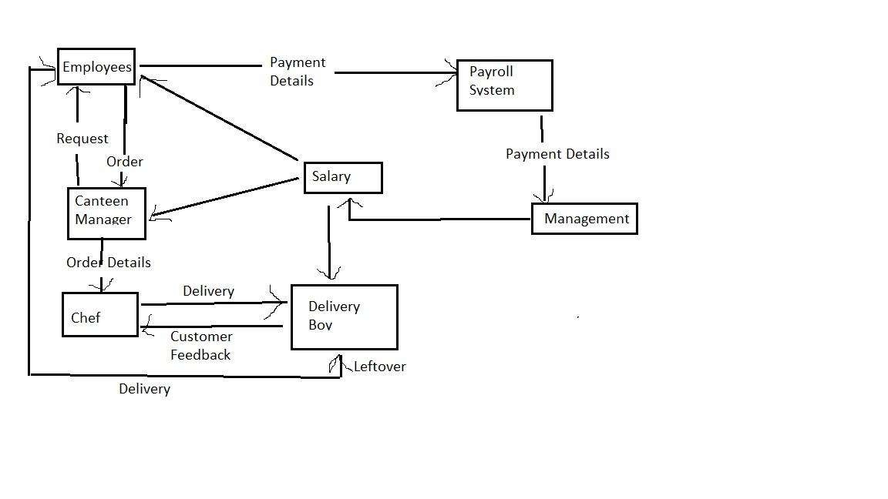

**In Scope**

* Supply food at whatever quantity the Employees want
* Can take detailed feedback for each food item and improve upon the quality
* Training for the Delivery Boys on how to work
* Regulate food wastage by each employee
* Store the payment information for every employee with the managers, to avoid from employees undercutting the Canteen by not paying what is due

**Out of Scope**

* Indulgence from other stakeholders of the Company
* Is not functional except for the employees of Unilever
* Food items can’t be used for the sales or marketing of the company
* Cannot provide different food items for people with different of different age, position
* Food cannot be delivered at any time the employee wants

**Activity Diagram for the System:**

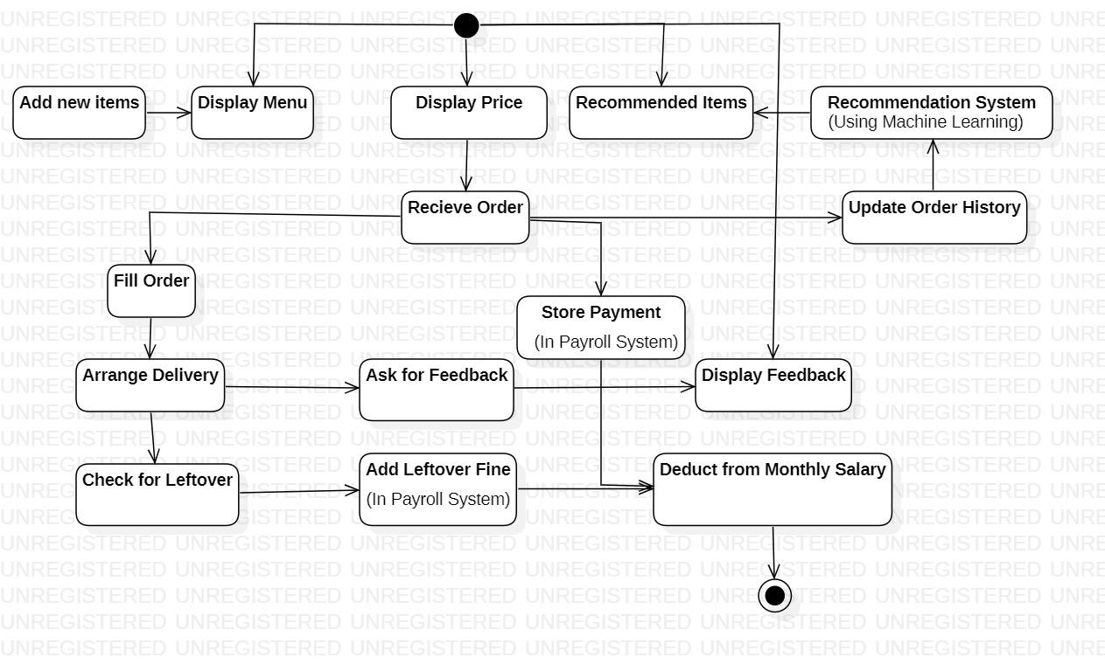

**ER Diagram for the System:**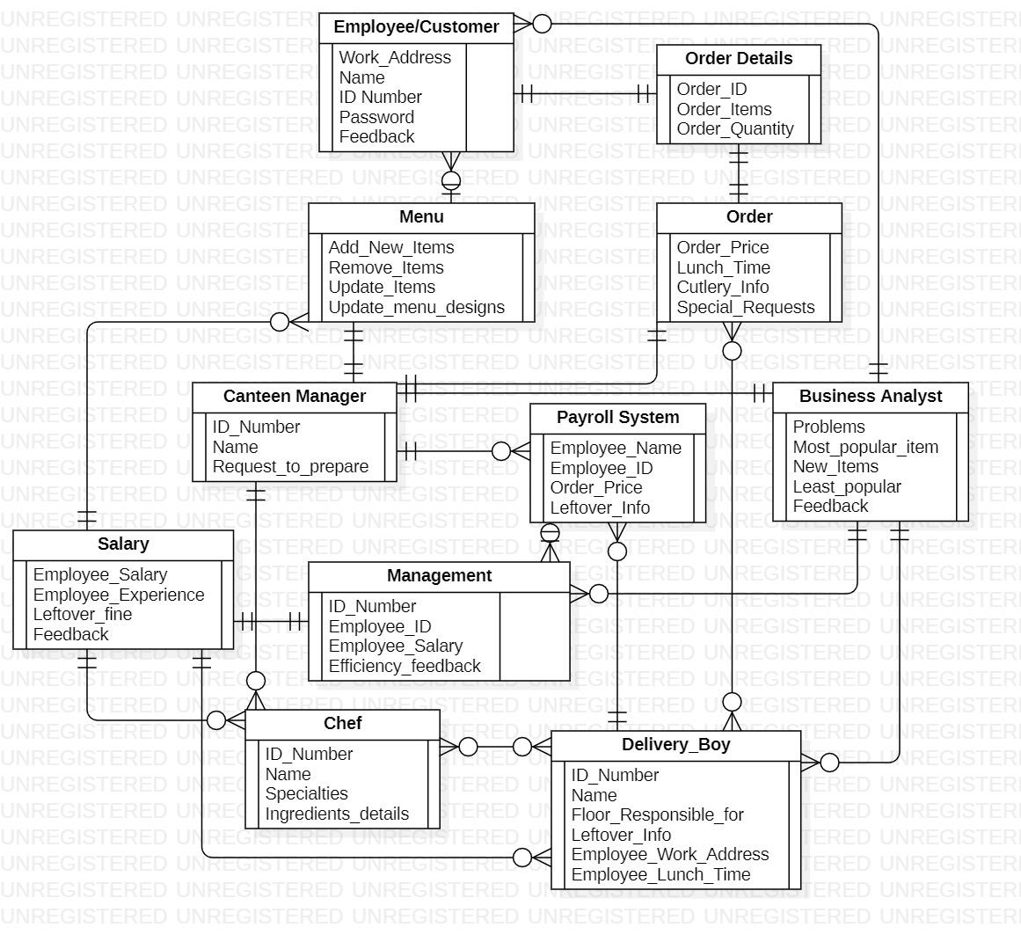

**Business Requirements:**

**Business objective – 1:**

Reduce canteen food wastage by a minimum of 30% within 6 months following first release.

**Business objective – 2:**

Reduce canteen operating costs by 15% within 12 months, following initial release.

**Business objective - 3:**

Increase average effective work time by 30 minutes per employee per day, within 3 months.

**Business objective - 4:**

By making the ordering process automated and by delivering the food to the user's workstation, the canteen will be able to operate with lesser manpower.

**Functional Requirements**

* The lunch order can be placed by employees latest by 11 am. After 11 am the system shall not allow the users to place orders for lunch items so that the chefs have sufficient time to cook the ordered dishes.
* The users can select the lunch dishes they would like to eat and create an order. They should be able to edit the items they want to order anytime before checking out.
* Once the order is confirmed and the user has checked out, they should **NOT** be able to cancel or edit the order.
* If a customer does not like any food item or is not happy with the delivery system by the canteen, they should be able to submit feedback.
* There is no payment gateway for the same so the payment for dishes ordered shall be deducted from employee’s salary. Hence, the employees need to enroll for salary payment deduction. The payroll system will handle payroll deductions.

**Nonfunctional Requirements**

* The system should be able to take at least 400 orders at one time to smooth things along.
* The Payroll system should effectively add the payments for everyday for each employee, without mixing the names and numbers up. It should make a separate table to store if there are any Leftover Fines for a particular employee.
* The System should not be faulty. It would lead to Unilever paying a lot of its revenue on its maintainance.
* The System should not be accessible to anyone whose does not work for Unilever.

**System Requirement:**

* The screens should be self-explanatory and very user friendly.
* The canteen ordering system is required to support a volume of 1500 employees ordering. the web pages should be light and render fast.
* The system should not lag during bad weather conditions.
* The system should not be too large in size, as in to affect the storage space of the device.

**Usability:**

The screens should be self-explanatory and very user friendly. Management would not want employees not ordering from the system as they cannot understand the screens and data fields on screen.

**Environments**

We are going to be creating and maintaining the program in Java. We chose Java because it will not change much over time, and if we make it well, there will be very little maintenance to be done on the code.

**Sample UI**

<https://docs.google.com/document/d/1qW2gjO-12rwyDkl7c_rxC8TGY_ErBrX6/edit?usp=sharing&ouid=111564240417976946191&rtpof=true&sd=true>

**Source Code**

https://docs.google.com/document/d/15lYwJOk9yXICdO5KoUQ-h0NsVWtLJ4ze/edit?usp=sharing&ouid=111564240417976946191&rtpof=true&sd=true